Queries re Scrivener Feedback:

- Translation for “View”:

There is a bit of discussion about the correct translation for “View”.

It was originally translated as “Anzeigen”, but then changed to “Darstellen” following client feedback:

- In the German version, the “View” menu is currently translated as “Anzeigen”. All Apple apps translate this as “Darstellung”. Using “Anzeigen” causes the app to crash on Touch Bar machines; using “Darstellung” has no such problems.

There were several comments that “anzeigen” would be preferable, and in fact I agree: My comments for main menu "Projekt"
In generell I guess the wording "darstellen" is not perfectly right for calling up an option or to view things on screen. It's not wrong but the better word is "anzeigen" (displayed).

Would it therefore be ok to change “darstellen” back to anzeigen within an instruction like “view screen”?

- There were several queries for the term “Ausschnittdienste”. To my knowledge that is the normal term for media researchers who find relevant snippets on information in newspapers (where they physically cut them out) and now in digital media.

See for example: http://de.prtargeting.com/faq/ausschnittdienst-und-medienbeobachtung/

Query: 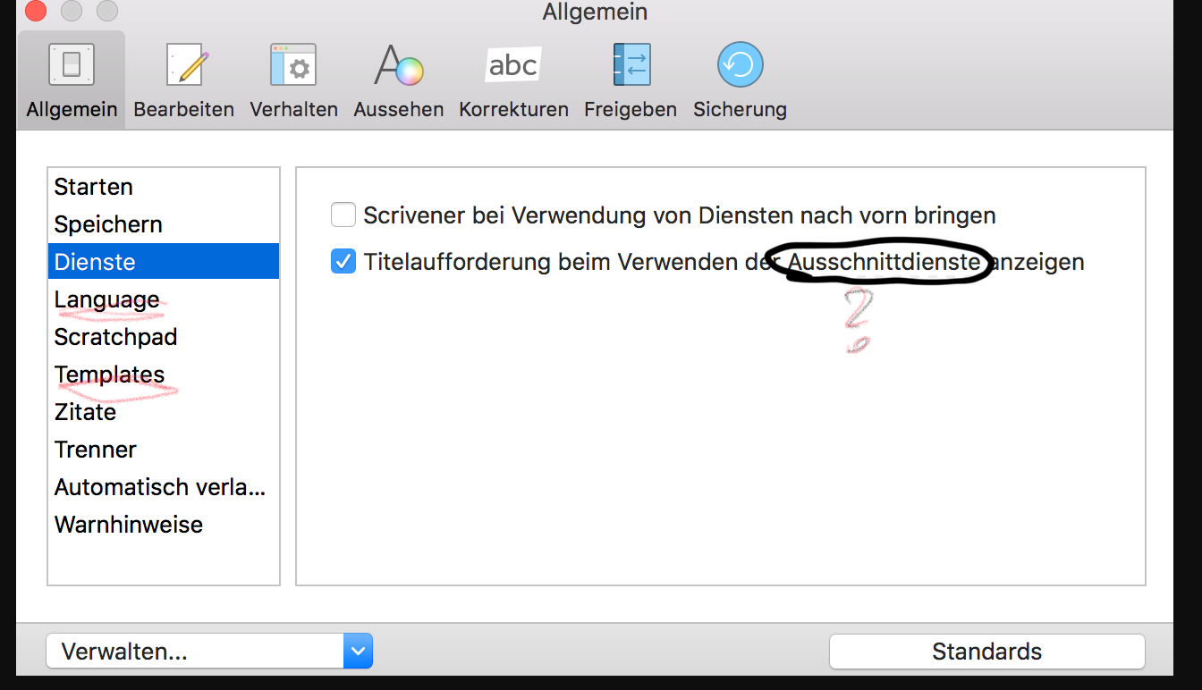

- Pause: See comment: "Pause" means "a break", not a good fit. Since you also gather other format options under that menu topic I'd rather call it "Sonderzeichen" (Special formats).

I’ve been trying to find this instance of “Pause”, but as far as I can tell, the instances I see in the translation are to do with pausing/replaying speech/screenplay etc. Would it be possible to pinpoint where this occurs?

- Transformationen/transformieren/umwandeln

I saw the following feedback in the thread:

Thomas: I've just had a look through the old feedback thread, and it does seem that the translator has fixed a lot of typos that were pointed out there and take some on board. Could some of it be down to a disagreement over the best term. For instance, you suggested:
[Bearbeiten] -> »Transformierungen« Change it to: »Umwandeln«
But it seems that Pages uses Transformationen, which we should therefore really be using, because we really want to make the translations conform to what is common in other apps, especially Apple apps.

Does this mean that “Umwandeln” should be changed back to “Transformieren”?

- Rosafarbener Marker:

I can’t find the colour translations in my document, and in particular not “Rosafarbener Marker”.
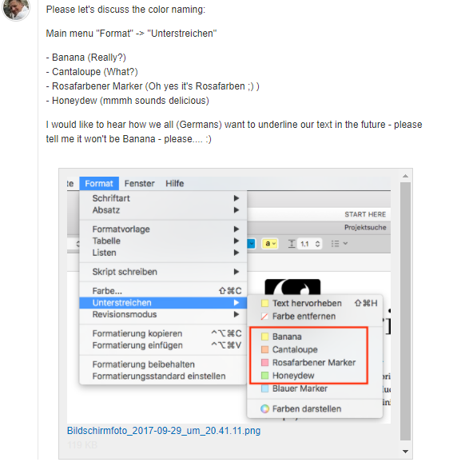

- Titelei:

As far as I know this is the correct translation for “Front matter”, and my googling doesn’t come up with any alternative for this technical term.

https://www.duden.de/rechtschreibung/Titelei

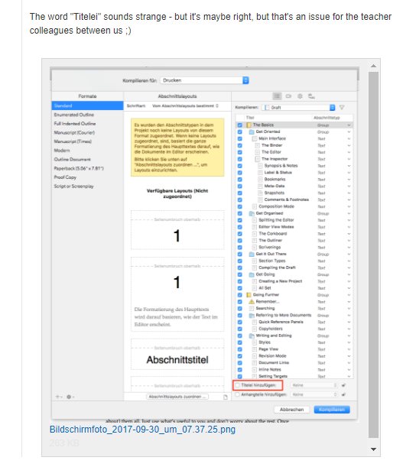

- Missing space:
I cannot find this text in the translations, so can’t insert the missing space.

- Import/Importieren, export/exportieren

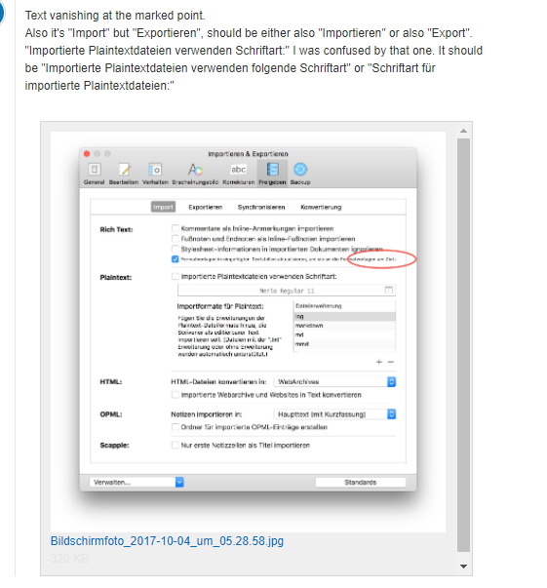

These look correct to me in translation – could this perhaps be a case of missing translations?

- Typo “lader” should be laden:

I think this is an issue of text cut off rather than a typo, as correct in translation

